# 

# Do we know how much the Scottish Government has spent on tackling child poverty?

## An attempt to uncover outturn expenditure on measures in the tackling child poverty delivery plans

# Contents

Introduction 2

Purpose 2

Methodology 2

Intended method 3

Amended method 4

Results 4

Spend on actions featuring in delivery plans and progress reports 4

Spend on actions where tackling child poverty is the primary aim of the policy 10

Discussion 13

Recommendations 16

How do these figures differ from the Scottish Government’s Progress Reports? 17

References 20

## Introduction

Tackling Child Poverty is cited as the number one priority of the Scottish Government and a set of statutory targets should be leading to dramatic falls in child poverty. However, progress has not been as fast as hoped, with the interim targets set for 2023/24 not met. As we look ahead to the next, and final, child poverty delivery plan due before the end of March 2026, understanding efforts to date on child poverty is crucial to know what has worked, what hasn't, and most importantly, why. The level of fiscal resource allocated towards actions to tackle poverty is a key part of building this understanding.

This analysis attempts to piece together outturn expenditure on actions that have been taken forward to date on tackling child poverty. This builds on and improves the current process of tracking spend in annual progress reports by verifying that the spend has actually taken place and attempts to match spend to all actions that should be impacting on the drivers of child poverty.

Our analysis covers the period 2018/19 to 2023/24. The data included latest Scottish Government progress report published in June 2025 covers 2024/25 and was published too late to include in this analysis, and indeed too early for outturn data for 2024/25 to be fully available. However, we have reviewed the 2024/25 progress report and are content that our discussion and recommendations remain applicable.

This analysis is a collaboration between the Fraser of Allander Institute and the Joseph Rowntree Foundation.

## Purpose

The purpose of this analysis is to review outturn expenditure to date by the Scottish Government that corresponds to reducing child poverty in line with the Child Poverty (Scotland) Act 2017. This is part of a wider project to help better understand Scottish Government outturn expenditure in recent years. Further analysis covering the whole Scottish Budget will be published later this year.

This analysis collates available information on outturn expenditure by the Scottish Government, either directly or via third parties (e.g. local authorities, charities). We have only been able to include information where it is publicly available, and where we are confident that it corresponds to outturn expenditure. The degree to which this is possible is in itself a test of the fiscal transparency of the Scottish Government.

We are focussed on spending that the Scottish Government has itself designated as spend that will contribute towards meeting the statutory child poverty targets, either as part of the two tackling child poverty delivery plans (Every Child, Every Chance (1) and Best Start, Bright Futures (2)) or as part of any additional measures added to the tables of actions in the annual progress reports (3-8).

We had hoped that this analysis would help with gaining a better understanding of expenditure on child poverty since the passing of the Child Poverty Act. However, issues with accessing publicly available information on outturn expenditure has meant that we only have a partial picture of spend. We therefore also provide recommendations on how to improve transparency to enable better monitoring and scrutiny of expenditure related to child poverty.

## Methodology

The analysis in this report is focussed on expenditure by Scottish Government, regardless of the delivery mechanism. This report includes outturn expenditure where we are confident that this money has left the Scottish Government. This may be from money that has been passed to local authorities or grants to the third sector. However, we are not including figures unless we can be confident that this transfer has occurred. Announcements of funds and budget allocations do not always mean that the money leaves the Scottish Government. Whilst we have tried to follow the money as closely as possible, we think there may be instances where money has been recouped by the Scottish Government (for example, after initial allocations have been set) that we have not been able to take account of.

To be included in this analysis, expenditure needs to relate to an action to tackle child poverty. This means that they relate to drivers of child poverty, either through income or reducing the cost of living. These are listed in each progress report in tables titled ‘Progress against actions and impact on priority families’ in the 2018/19, 2019/20, 2020/21 and 2021/22 progress reports, and ‘Overview of progress’ in the 2022/23 and 2023/24 progress reports.

We are not including actions that are within Every Child, Every Chance Chapter 5 ‘Helping Families in Other Ways’ or Best Start, Bright Futures Part C ‘Supporting the Next Generation to Thrive’. The actions in these parts of the delivery plans do not directly impact on the drivers of poverty within the time frame of the statutory targets.

### Intended method

#### Scottish Government designated spend

Our intended method was to utilise the Online System for Central Accounting and Reporting (OSCAR), a UK Government database and financial management system used by HM Treasury to collect, consolidate, and report UK and devolved governments’ expenditure data.

This data provides descriptions of expenditure and details including the type (e.g. revenue/capital) and category (e.g. pay, rental costs, current spend) and the delivery mechanism (e.g. grants to local authorities, transfers to households, lending to the private sector).

The Scottish Government provides expenditure data to HMT for the purposes of OSCAR, and we had hoped that the same level of detail as found for UK government departments would be available for analysing spend in Scotland. This would have meant that every line of spend would be broken down with a helpful descriptor, that we could then trace through to actions in the child poverty delivery plans.

However, on further examination, the disaggregation of spend provided by the Scottish Government to HMT for the purposes of OSCAR is less detailed than the case for UK Government departments. This meant that the OSCAR dataset couldn’t be used, as hoped, for this analysis. We also found that, even where there was comparable disaggregation of data in the OSCAR dataset for Scotland, some of the relatively small amounts of spend linked to some of the child poverty actions would not be captured in subsegments.

There are also other instances where specific subsegments do exist and can be easily identified, such as for some social security payments. However, the data in OSCAR is inconsistent with other published data sources, such as statistics on spend published by Social Security Scotland (SSS).

#### Additional local government spend

Our intention had been to augment the OSCAR analysis with detail from Local Financial Returns (LFRs) to provide detail of income received by local government funded through specific (and sometimes ringfenced) grants. For the most part, local government reporting through LFRs has been detailed enough for this purpose, with a few notable exceptions including the recording of expenditure on local employability programmes. This is discussed later in this paper.

### Amended method

To overcome the limitations of the Scottish data available from the OSCAR dataset and to provide the necessary level of detail, we have followed a bottom-up approach and sought outturn spend information from a range of sources.

Progress reports provide some figures related to actions, but according to the Scottish Government, they comprise a mixture of outturn, budgeted, and forecasted figures, depending on what was available at the time of writing. However, it is not always clear from the progress reports which figures are outturn, and we have therefore sought to triangulate figures using other sources, including evaluation reports, audited accounts of third sector organisations and published FOI responses. For social security policies, we only include spend above the Block Grant Adjustment to better capture spend that is allocated from within the Scottish Budget. More information on how our approach how differs from existing analysis produced by the Scottish Government is covered later in this report.

We have not been able to locate outturn expenditure for every policy where spend has taken place but for those actions where we have found outturn expenditure, we sum these figures to provide a range estimate, with the lower estimate representing actions where tackling child poverty is the primary aim of the policy, and the upper range representing actions where tackling child poverty is a secondary, or indirect, aim of the policy.

These figures can’t claim to be total spend, and instead should be interpreted as total spend where the figures can be independently verified. With more transparency on outturn expenditure, we would be able to revisit this analysis to provide a more comprehensive analysis of total Scottish Government spend on tackling child poverty.

## Results

### Spend on actions featuring in delivery plans and progress reports

We have used the same separation of the drivers of child poverty as the Scottish Government: employment and earnings, social security, cost of living and an additional category which captures actions that don’t fit into these categories, including from 2022-23 onwards a new ‘People and Place’ category (we have labelled this ‘other’).

The charts in this section provide figures where we are either confident that the progress report is reporting outturn spend (including spend the ‘Child Poverty Fund’) or where we have found a secondary source of data that provides a reliable figure of outturn spend.

If actions are not included within this section, this signifies that we can’t confirm the level of outturn expenditure. This does not necessarily mean that no spending occurred, but that no data has been published that allows us to verify this. It may also be the case that the policy is still in development and expenditure will follow at a later date. Unless otherwise stated, outturn expenditure is in nominal terms with real terms totals provide for reference.

We only include expenditure after inclusion in either a delivery plan or progress report. For example, the Adult Disability Payment (ADP) was not included in Every Child, Every Chance and therefore only features in our analysis after its inclusion in Best Start, Bright Futures. Some policies were not included in either delivery plans but were added as actions in subsequent progress reports and we have included these from the date of the progress report that they appeared within (e.g. if an action first appears in the 2019/20 delivery plan, spend for 2019/20 and beyond is included).

#### Employment

We identified 13 actions related to employment where we were able to find outturn expenditure data. Most actions related to the first delivery plan. There were 23 actions that we were unable to find expenditure for, and the majority of these are actions from the second delivery plan ‘Best Start Bright Futures’; or were added to as part of the 2023/24 progress report.

The largest elements of funding related to child poverty are connected to employability programmes, primarily Fair Start Scotland and support for parental employability (for which various names are used across the progress reports).

Unravelling the various elements of employability as they appear in the delivery plans and progress reports has been difficult. This is due in large part to the introduction of the No One Left Behind approach to employability funding which has led to the Scottish Government transferring funding, and some flexibility, to local government.

A number of spending lines that feature in this analysis are now part of No One Left Behind. For actions that pre-exist transfer into No One Left Behind (for example, on parental employability support), the progress reports are continuing to assign outturn spend to that action and the Scottish Government is still separating this out in allocations to local government (9). However, a number of new actions from Best Start, Bright Futures do not have assigned outturn spend and are instead referred to as being delivered within No One Left Behind (test and learn pilots for lone parents, challenge fund).

Unfortunately, there are no central sources that we are aware of that report on No One Left Behind outturn spend that relates to actions on child poverty, or by client group. If we were to use the total quantum of funding (reported in the progress reports as £83m in 2022-23 and £103m in 2023-24) for No One Left Behind, this would be inconsistent with the reporting on employability spend linked to child poverty in the preceding years. However, if we do not include this spend, we know we are under-reporting spend that the Scottish Government has assigned towards tackling poverty. We have taken the latter approach here, and have included in our discussion and recommendations that would allow us to count more expenditure here.

Chart 1 shows the different actions that we have included in this analysis, alongside a line that shows the total in 2025/26 prices. In real terms, the expenditure we have been able to report rose over the period of the first delivery plan but has declined over the period 2022-23 and 2023-24. This is likely to be be in part due to difficulties in reporting expenditure on employability, including for No One Left Behind. However, we know that some funding ended, for example, the Flexible Workforce Development fund was stopped in 2023-24 (10).

###### Chart 1: Outturn expenditure on actions related to employment

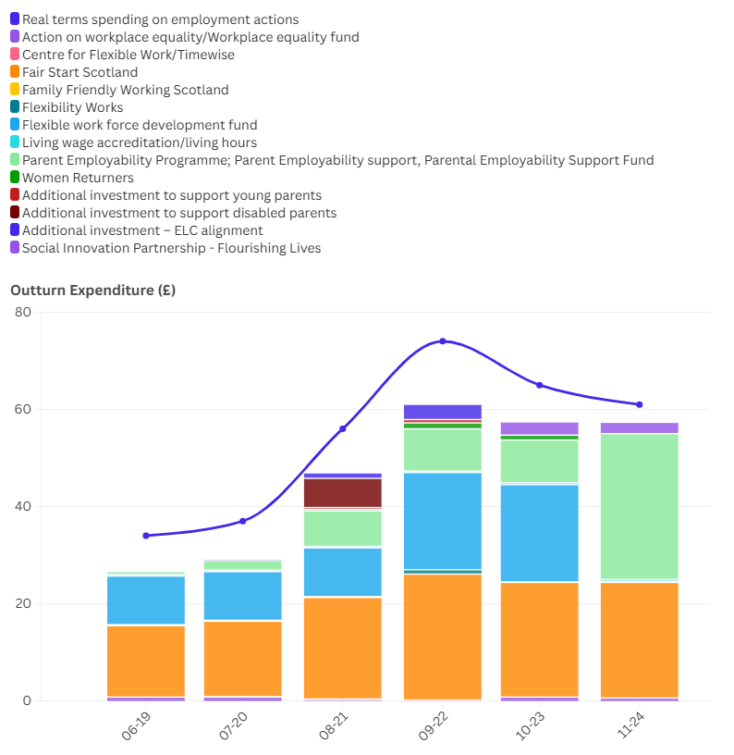

#### Social Security

We identified 14 social security actions where we could independently verify outturn expenditure. We were unable to find expenditure linked to 5 social security actions, but this is because the actions did not necessitate additional spending rather than because of incomplete information. The totals we report therefore are representative of the total spend on social security linked to actions in progress reports.

For some of the actions (including the Carer Support Payment/Carer’s Allowance) we have only included expenditure above the amount funded by the UK Government. This diverges from the approach taken by the Scottish Government. However, we have also included some actions that the Scottish Government do not count within their estimated spend. Further details of our approach and how it differs from the Scottish Government is included in a later section of this report.

###### Chart 2: Outturn expenditure on actions related to social security

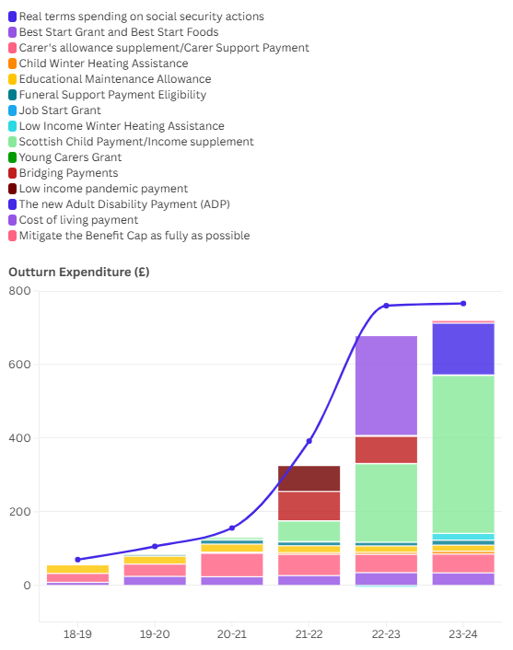

#### Cost of Living

We found outturn expenditure for 27 actions related to the cost of living with a further 31 actions where we could not find or verify outturn expenditure information. The actions related to cost of living are dominated by the affordable housing programme and expanded early learning and childcare. The action on affordable housing is to ensure that that future affordable housing supply decisions have a real and sustained impact on child poverty, and arguably by including the entire outturn spend directed to the programme, we will be overstating its impact. Chart 3b shows the same data but without the affordable housing and early learning and childcare spending lines.

Other actions which are notable in size include the efforts to reduce food insecurity in the school holidays and concessionary travel for under 22s. Some actions appear to be short lived allocation of funds and a number of actions only featured in the first delivery plan and were not included in the second plan – for example, support for affordable credit. When the affordable housing budget is included, in real terms (2025/26 prices) outturn expenditure has wavered and spend in 2023/24 is only marginally higher than in 2018-19. With the affordable housing and early learning and childcare funding removed, there is more of a clear upward trajectory of spend in both nominal and real terms.

###### Chart 3a: Outturn expenditure on actions related to cost of living

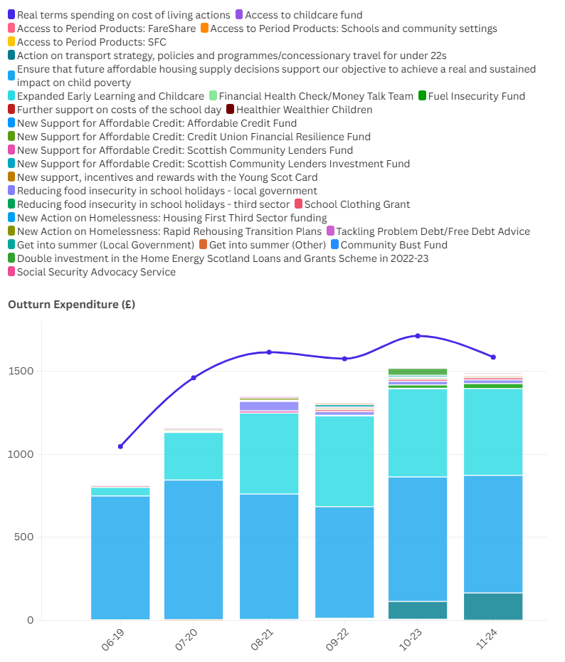

###### Chart 3b: Outturn expenditure on actions related to cost of living without affordable housing

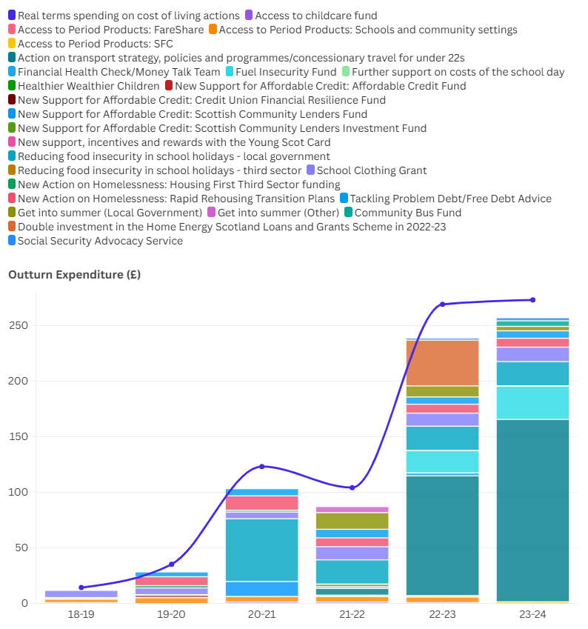

#### Other actions

In the second delivery plan, Best Start, Bright Futures, a number of actions were included within a section called People and Place. We have tracked these through to the progress reports where only a small number became part of the narrative on tackling child poverty within the timelines of the 2030/31 targets.

Out of the actions that are part of efforts to meet the targets, we have located outturn expenditure figures for 4 actions, and expenditure for one further action ‘Act on findings of Rural and Islands Poverty Research’ couldn’t be found.

Whole Family Wellbeing funding is the largest part of expenditure in this section, and as it has been held flat in cash terms, this represents a real terms decline over the period 2022-23 to 2023-24.

###### Chart 4: Outturn expenditure on other actions

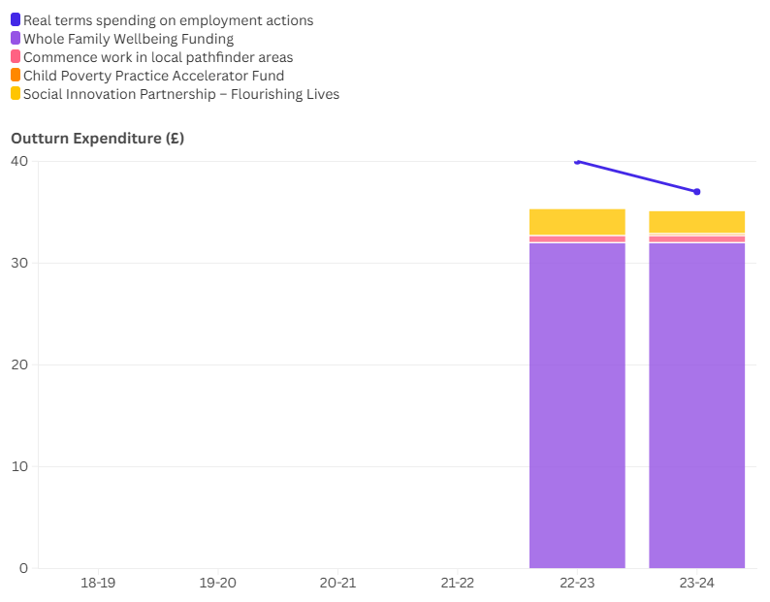

### Spend on actions where tackling child poverty is the primary aim of the policy

Across all categories of spend, we have looked at evidence and made a judgment on whether the outturn expenditure relates to an action where tackling poverty is the primary focus. For example, the outturn expenditure on the affordable housing programme does not have the primary aim of reducing child poverty, albeit this is a related aim, and therefore not all those who benefit will be children in or at risk of poverty. Other policies, such as the Scottish Child Payment have reducing child poverty as a primary aim.

The charts in this section provides a sum of independently verified outturn expenditure related to actions that are primarily focussed on child poverty.

Chart 5 shows that, there has been a real terms increase in spend with a primary aim of tackling child poverty since 2018-19. 80% of the increase is from social security spending, and the vast majority of this is the Scottish Child Payment.

Chart 6 provides context by illustrating the total spending on actions primarily focused on tackling child poverty as a proportion of overall Scottish Government expenditure. This share has grown over time, and as of writing, confirmed outturn figures show that such spending accounted for 1% of total Scottish Government expenditure in 2023/24.

###### Chart 5: Outturn expenditure on actions primarily related to tackling child poverty

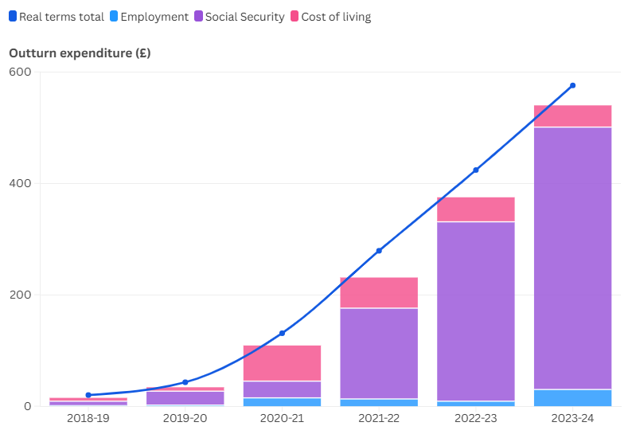

###### Chart 6: Outturn expenditure on actions primarily related to tackling child poverty as a proportion of total Scottish Government spend

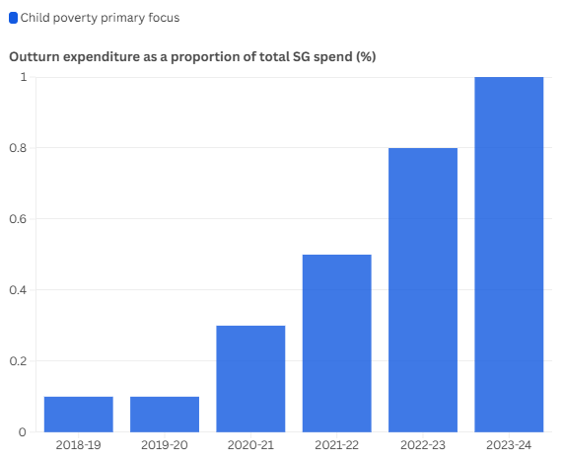

## Discussion

Our analysis was unable to answer the question we started with which was how much money has been spent on child poverty actions by the Scottish Government since the Child Poverty (Scotland) Act came into effect. This is primarily due to a lack of transparency on outturn data.

A key concern is that the Scottish Government’s progress reports on child poverty often do not distinguish between outturn expenditure and budgeted or forecasted spend.

To cross-check figures in the progress reports to determine outturn expenditure, we sought to locate other sources of data on outturn spend. This was a difficult and time-consuming process.

Transparency matters, not only for enabling external scrutiny of spending, but also to ensure officials have access to the information they need to monitor and report progress on tackling child poverty. Understanding what has been spent on tackling child poverty to date is surely a pre-requisite of being able to meaningfully assess progress and understand what additional resources are required to meet the child poverty targets.

There is an opportunity to build on the existing reporting frameworks. Since progress reports already attempt to collate expenditure figures, a process of reviewing existing figures and checking these against outturn should be possible.

Some progress has been made in fiscal transparency. The publication of the 2025-26 Scottish Budget included a breakdown of outturn spend at for 2024-25 at Level 4s (a relatively detailed level of disaggregation of spend). This will mean that for future updates of this analysis, there will be more scope to cross check figures in the progress report with published outturn data. This will not cover all actions related to child poverty as things stand as some policies and programmes will be aggregated into level 4 figures and not be available at ‘action’ level. We would like to see stronger commitments to transparency in child poverty spending, which would also enhance scrutiny across other areas of expenditure.

* **Social security data**

As touched upon in the introduction section, we have encountered difficulties in identifying the primary and single source of truth on expenditure on devolved social security benefits. In our initial examination of the OSCAR data, it appeared that dedicated subsegments would allow us to identify expenditure on most devolved benefits of interest (although not the Scottish Child Payment as this is included in a broader subsegment). However, on closer examination, these figures are different from the statistics produced by Social Security Scotland, which produces regular statistical outputs on each benefit individually.

Both of these source’s feed into other annual publications, such as Government Expenditure and Revenue Scotland (GERS) and the Fiscal Framework Outturn Report, but again there is a lack of consistency between these publications.

After seeking advice from the Scottish Fiscal Commission, we have used data from their Forecast Evaluation reports and the Fiscal Framework data annex, which was published alongside the Scottish Budget in December 2024. Where necessary we have also used Social Security Scotland Annual Reports. For benefit payments with a corresponding BGA, we have used data produced alongside the Scottish Fiscal Commission's Forecast Evaluation Reports in Supplementary spreadsheets, which gives figures which are consistent with Social Security Scotland Accounts (after all overpayments and other adjustments are accounted for) for the payments, and data from the Fiscal Framework Data Annex for the BGAs. For those benefits without a corresponding BGA, such as the Scottish Child Payment we have used the Scottish Fiscal Commission's Forecast Evaluation Report Supplementary spreadsheets. For those payments which are administered by Social Security Scotland, but not covered by SFC forecasting (such as the Young Carers Grant) we have gone through individual years of Social Security Scotland Accounts to get the figures, which should then be on the same basis as the figures produced by the SFC. The detail for the source for each payment is given in the accompanying spreadsheet

* **Employability expenditure**

As already discussed, tracking spending related to employability has become more difficult. This will continue to cause problems for monitoring outturn expenditure in the future.

It is unclear whether Scottish Government have set up appropriate monitoring frameworks to capture outturn expenditure that encapsulates programmes that are part of No One Left Behind allocations. To do so, they would also need to collate information on spend related to funding that comes from other sources of public funding (General Revenue Grants and Council Tax income). This would allow them to understand whether the additional money for No One Left Behind is being passed through, as opposed to being used to offset cuts in employability spend elsewhere.

There are examples of some annual reports that do present outturn spend by funding source (for example, Shetland’s Local Employability Partnership 2024/25 investment plan has outturn spend against budget for 2023/24(11)) but we haven’t been able to source published copies of reports from other parts of Scotland, and therefore do not know whether they all contain this information on outturn. Certainly, there appears to be no collation of information from local authorties on outturn spend by Scottish Government despite clear guidelines given to local authorities on how some of the funds must be spent.

We also note that there is no Local Finance Return on employability as there are for other areas (i.e. Early Learning and Childcare) with employability spend being contained within a larger budget line related to Economic Development in LFF 07.

* **Spending to the Third Sector and disparities in reporting requirements**

There is insufficient transparency in the reporting of funding provided to third sector delivery partners. In many cases, we have only been able to identify this information through the published accounts of the organisations themselves. It feels inappropriate that charities are held to a higher standard of financial transparency than the Scottish Government in this context.

* **Reporting on funds**

Many interventions are delivered through competitive funds that organisations—often third sector groups or local authorities—must apply to. While the total value of these funds is usually announced publicly, it is often unclear how much is actually spent in a given year, or in total. Information is sometimes only made available through Freedom of Information (FOI) requests. A more transparent and proactive approach to reporting on the use of these funds would be welcome. An example can be seen here: [Debt Advice Levy Funding](https://www.gov.scot/publications/debt-advice-levy-funding/).

* **Governance approach**

The Code of Practice for Statistics is an existing framework to ensure quality, trusted, timely data is published which provides public value. Given the importance of child poverty as a government priority, the standards applied here should therefore be in line with best practice. This should include proactively addressing any apparent inconsistencies in data from different statistical publications and sources (e.g. financial reporting and Social Security Scotland statistics) and co-ordinating across delivery agencies and departments to ensure that the information published adds transparency.

## Recommendations

1. **Improve clarity on types of spend in progress reports**

In progress reports, the Scottish Government should clearly distinguish between:

* + Audited outturn expenditure
  + Estimated spend
  + Budgeted allocations

Each progress report should include a multi-year breakdown of expenditure by action or programme, either in the main report or as a supporting annex. This should be revised to take account of outturn information when it becomes available.

The process of confirming outturn expenditure should be completed in advance of the third and final delivery plan, due in 2026.

1. **Improve approach for reporting for employability spend**

Consider financial reporting by local areas on No One Left Behind, for example, through an additional LFR return as has been done for ELC of through collating information already gathered from local areas.

1. **Apply consistent transparency standards**

Routinely publish data on how much is awarded and spent through grants or contracts with third sector delivery organisations.

1. **Improve reporting on competitive funds**

For all Scottish Government-administered funds (e.g. third sector grants, local authority challenge funds) publish annual breakdowns of actual spend (not just total allocations or fund size) and report this data in a centralised and routinely updated public source, to avoid reliance on FOI requests.

1. **Strengthen governance and accountability**

Establish clear internal guidance within the Scottish Government on the minimum data standards for monitoring and reporting on delivery plan spend. Consider assigning responsibility for financial oversight to a dedicated team or lead official to ensure consistency across departments and funding streams. Consider the application of the Code of Practice for Statistics and/or oversight of the Head of Profession

## How do these figures differ from the Scottish Government’s Progress Reports?

With the Scottish Government Progress Reports, a number of tables are provided.

The two of most interest to our analysis is:

1. A table of actions which summarises the actions from delivery plans[1] that link directly to the drivers of poverty and provides an update on progress.

To qualify as actions, they must have a direct link to one or more of the drivers of reducing child poverty and hence meeting the targets.

1. A table that provides an estimate of the amount of money spent (where available[2]) on children in poverty. Some but not all, overlap with delivery plan actions.

This builds on building on a methodology that the Fraser of Allander Institute and the Joseph Rowntree Foundation produced following the 2019/20 Scottish Budget. The aim of the original FAI & JRF analysis was to improve the transparency in reporting of the quantum of spending that has a link to child poverty in the budget for the year ahead.

However, it is not an ideal method for monitoring spend on government actions towards meeting the statutory targets. Some of the spend relates to improving outcomes for children who are in poverty but with no direct link to the drivers of child poverty and hence the statutory targets. This includes spend within the education system focussed on reducing the attainment gap which won’t reduce poverty now but could reduce the impact of poverty on those children.

This new report aims to fill this evidence gap by providing an estimate of **money spent on actions to reduce child poverty.** This utilises the information in the table of actions, locates information in money spent in each and every year since that delivery plan was published, and shows this in the context of the overall Scottish Government budget.

Our aim is to show the extent to which Scottish Government has prioritised resources to meet the statutory targets.

Some of actions in the delivery plans are not only targeted at child poverty. For example, early learning and childcare is a universal service so whilst it will help reduce the cost of living for parents in poverty and for some help maximise earnings from paid work, it would be wrong to attribute the whole cost of the public service towards tackling poverty. Similarly, increases to the carer’s allowance in the first delivery plan will benefit households with children in poverty where there is a carer, but not all households with a carer will have children, nor be in poverty.

The Scottish Government, in their analysis of policies directed at children in poverty, exclude some policies, including early learning and childcare from their totals, as well as a number of other policies[3]. Excluding these entirely feels like it will underestimate the governments spend.

However, they include others such as the uplift to Carer’s Allowance which although will help reduce poverty for some children, it is not targeted directly at doing so. Including these types of policies, where reducing child poverty is a secondary consideration of the policy, will overestimate the amount of spend the government has put towards tackling child poverty. Where possible, the Scottish Government have used data available on service use to determine how many children in, or at risk of, poverty are beneficiaries of the spend. In the absence of this information, they use poverty statistics to provide an estimate of the amount targeted at children. For example, for Carer’s Allowance, the total spend in 2023/24 is reported as £359.10. The statistic of children in poverty was 22% for 2020-23, and this proportion is used to produce an estimate of the spend on children in low-income families (£79m). Whilst this estimate is perhaps more realistic (in that it doesn’t assume that all households who claim carer’s allowance have children) we can’t be confident that this is close to the correct amount.

Our approach is to produce a range estimate, with the lowest end of the range limited only to policies where the primary aim of the policy is to reduce child poverty (or where we have verifiable information on the number of children who benefit from a service[4]), and the highest range of the spend including all policies that are listed in the delivery plan actions.

There is also a number of policies that we could exclude on the basis that they were in existence before the child poverty statutory targets were put into legislation, and therefore it could be argued that they are less relevant to new efforts to meeting the targets. It could however be argued that by continuing these policies, they are making a contribution to meeting the targets (i.e. in their absence, child poverty would be higher). The one area where we have felt justified in limiting analysis to ‘new spend’ is for social security spending related to devolved benefits, including cares and disability payments. The devolution of these policies included a transfer of resources from the UK Government to the Scottish Government which, broadly, covers the cost of the policy if the Scottish Government provided the same policy as the UK Government. The difference between Scottish Government spend, and the equivalent UK Government spend is can be calculated by looking at Scottish Government spend which exceeds the Block Grant Adjustment funding that comes from the Scottish Government on social security.

This can be thought of as UK Government funding for social security in Scotland. If we were to include this spend, it would be arguable that we should be including UK Government spend on other social security spend, such as Universal Credit.

The approach we have taken here is not the same as the Scottish Government, who include the whole spend of Carer’s Allowance in their table of spend on children in poverty, not just the additional spend put funded from elsewhere in the Scottish Budget, which relates to the Carer’s Allowance Supplement.

## References

1. Government S. Every Child, Every Chance Tackling Child Poverty Delivery Plan (2018-2022) 2018 [Available from: <https://www.gov.scot/binaries/content/documents/govscot/publications/strategy-plan/2018/03/child-chance-tackling-child-poverty-delivery-plan-2018-22/documents/00533606-pdf/00533606-pdf/govscot%3Adocument/00533606.pdf>.

2. Government S. Best Start, Bright Futures Tackling Child Poverty Delivery Plan (2022-2026) 2022 [Available from: <https://www.gov.scot/binaries/content/documents/govscot/publications/strategy-plan/2022/03/best-start-bright-futures-tackling-child-poverty-delivery-plan-2022-26/documents/best-start-bright-futures-tackling-child-poverty-delivery-plan-2022-2026/best-start-bright-futures-tackling-child-poverty-delivery-plan-2022-2026/govscot%3Adocument/best-start-bright-futures-tackling-child-poverty-delivery-plan-2022-2026.pdf>.

3. Government S. Every Child Every Chance First Year Progress Report (2018-19) 2019 [Available from: <https://www.gov.scot/publications/tackling-child-poverty-delivery-plan-first-year-progress-report-2018-19/>.

4. Government S. Every Child Every Chance Second Year Progress Report (2019-20) 2020 [Available from: <https://www.gov.scot/publications/tackling-child-poverty-delivery-plan-second-year-progress-report-2019-20/>.

5. Government S. Every Child Every Chance Third Year Progress Report (2020-21) 2021 [Available from: <https://www.gov.scot/publications/tackling-child-poverty-third-year-progress-report-2020-2021/>.

6. Government S. Every Child Every Chance Fourth Year Progress Report (2021-22) 2022 [Available from: <https://www.gov.scot/publications/tackling-child-poverty-delivery-plan-fourth-year-progress-report-2021-22/>.

7. Government S. Best Start, Bright Futures First Year Progress Report (2022-23) 2023 [Available from: <https://www.gov.scot/publications/tackling-child-poverty-delivery-plan-annual-progress-report-2022-2023/>.

8. Government S. Best Start, Bright Futures Second Year Progress Report (2023-24) 2024 [Available from: <https://www.gov.scot/publications/best-start-bright-futures-tackling-child-poverty-progress-report-2023-24/>.

9. Government S. Employability support funding in Scotland: FOI Release 2024 [Available from: <https://www.gov.scot/publications/foi-202400423267/>.

10. Education Children and Young People Committee. Pre-Budget Scrutiny 2025 to 2026. 2024.

11. Shetland Local Employability Partnership. Annual Investment Plan 2024-25. 2023.

1. There are a small number of policies that are mentioned for the first time in Progress Reports. We have included these actions.
2. According to the Scottish Government, “They comprise a mixture of outturn, budgeted, and forecasted figures, depending on what was available at the time.”
3. According to the Scottish Government “these estimates do not include spend on universal services from which children in poverty will also benefit, including services focused specifically on children such as funded Early Learning and Childcare and universal Free School Meal provision in primary schools, or wider support including free prescriptions, healthcare or free tuition. Disability benefits have also been excluded from the calculations, these are non-means tested and their purpose is to provide support to help with the additional costs associated with having a disability or long term health condition.
4. For example, from official administrative data or from robust data collected as part of monitoring and evaluation.